

May 21, 2012

INTRODUCTION

American Electric Power Service Corporation (AEPSC) is seeking proposals on behalf of one or more of AEPSC’s affiliated or associated companies for the supply of coal to one or more power plants.

This solicitation seeks coal that meets the specifications on the attached “Coal Specifications.” All proposals will have specifically negotiated terms and conditions, but will mirror those included in this solicitation as close as practicable.

AEPSC is seeking proposals for up to two million tons of coal per year, beginning in January 2013 and ending as late as December 2017 for the following:
- Term Barge coal (refer to Specification “A”)

AEPSC is seeking proposals for up to twenty-five thousand tons of coal per month, beginning in January 2013 and ending in December 2013 for the following:
- Spot Barge coal (refer to Specification “B”);
To access the blank Spot PO form, DOUBLE click on the link below:
Each valid proposal should include:
- The Seller’s and Producer’s name(s);
- The location of the mine;
- The mine type (surface or underground) ;
- The seam of coal being mined;
- The mine district;
- The quality of the coal, inclusive of suspension/rejection limits;
- The coal preparation (washed, crushed run-of-mine, etc.);
- The tons proposed for delivery each month;
- The stated price per ton;
- The commencement date and months of delivery;
- MSHA ID Number, Environmental Permits, and the intended method of mining (mountain top removal, contour, or deep) ; and
- The loading dock and respective river milepost

COAL PROPOSAL PACKAGE

A "Spot Coal Proposal Form" if applicable, or a “Term Coal Proposal Form” if applicable and a "Barge Transportation Facilities Information" sheet, shall comprise a “Coal Proposal Package.” Copies of these forms are contained herein. In order to ensure that proposals are responsive to AEPSC's needs, and that they provide a uniform basis for evaluation, any entity providing offers is required to complete a “Coal Proposal Package” for each submitted offer. Typical coal analyses, including the Proximate, Ultimate, Trace Element and Mineral Ash Analyses, Grindability Index, and Ash Fusion Temperatures, shall be submitted with the attached “Coal Proposal Package.”
BID SUBMITTAL

The “Coal Proposal Package(s),” which should be signed by a person having proper authority to legally obligate the offering company, provided along with any additional supporting materials, must be received no later than 5:00 p.m., THURSDAY, MAY 31, 2012. Proposals are to be kept open for AEPSC's acceptance until 5:00 p.m., FRIDAY, JUNE 15, 2012. All proposals are to be submitted by e-mail to coalrfp@aep.com, or by fax to (614) 583-1619 (Attention: Jason Rusk), or delivered in an envelope marked "AEPSC RFP - COAL PROPOSAL" and are to be addressed as follows:

AEPSC RFP – COAL PROPOSAL
ATTN: JASON RUSK, DIR., COAL PROCUREMENT
AMERICAN ELECTRIC POWER SERVICE CORP.
155 W. NATIONWIDE BLVD.
SUITE 500
COLUMBUS, OH 43215

If you do not wish to submit a proposal in response to this solicitation, please complete and return the attached "Decline To Offer" form on or before May 31, 2012.

BID EVALUATION

Proposals will be evaluated based upon the following factors:
- Delivered cost (cents per million Btu);
- Coal quality with appropriate price adjustments for guaranteed percent ash and pounds SO₂ per million Btu based on the relevant SO₂ emissions allowances, inclusive of rejection limits;
- Reliability of supply and transportation flexibility;
- Terms and Conditions;

AEPSC reserves the right to modify or withdraw this invitation, to reject any or all proposals, and to terminate any subsequent negotiations at any time. AEPSC also reserves the right to accept one or more proposal(s) for a portion or for all of the quantities of coal it seeks to acquire with this invitation.

AEPSC will retain in confidence all proposals and other information received pursuant to this invitation, except when the same is requested by a court or government agency or otherwise required to be disclosed.

Those submitting proposals shall be responsible for the completeness and accuracy of all information contained in and used in preparation of its proposal(s) and for having supplied all necessary information.

It should be noted that for payment purposes, weighing and sampling shall be performed at the same location pursuant to Sections 3 and 4 of the AEP Coal Procurement Terms and Conditions contained within the attached Spot Purchase Order.

All proposals shall be submitted by the offering company at their sole cost and expense.

Should further information be required, please contact Jason Rusk at (614) 583-6275 or Clint Stutler at (614) 583-6039.

Very truly yours,

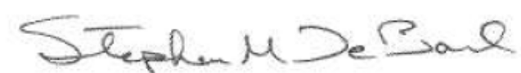

Stephen M. DeBord
Vice President – Fuel Procurement & Transportation
On behalf of American Electric Power Service Corporation

COAL SPECIFICATIONS

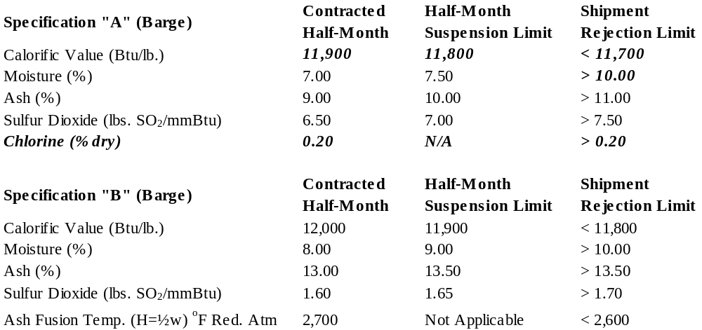

The above contractual specifications may not exactly match one or more of the coal types a prospective supplier may have, but should be included in the one that most closely fits such specification.
Spot Coal Proposal Form
Page 1 of 5
SPOT COAL PROPOSAL FORM
DATE:
Details concerning the supply of coal being offered herein to the American Electric Power Service Corporation (AEPSC) are provided below:

1. Seller: (If Seller is a Sales Agent, include full names, addresses, and telephone numbers of Sales Agent and Producer and attach Producer's signed authorization for Sales Agent to “exclusively” make an offer on behalf of Producer.)

(a) Seller: |  |  |  | (b) Producer:
2. Name(s) and location(s) of mine(s):
3. Quantity offered (tons per month):
4. Term
(The actual length of Term shall be designated by AEPSC in the event of its acceptance of offer. Seller is to specify the earliest month coal is available).
5. Bidder’s Shipping Point:

Barge Deliveries
Shipping Point(s): | Dock:
 | River:
 | Milepost:
6. Pricing ($/short ton) |  | FOB Barge:

Spot Coal Proposal Form
Page 2 of 5

7. Type of Mine(s):
Surface | %
Underground | %
8. Mine District:
9. Name of Seam(s):
10. Preparation:
Crushed, run-of-mine | %
Washed | %
11. Comments:

Spot Coal Proposal Form
Page 3 of 5
12. Guaranteed “Spot” coal specifications “As-Received”:

The quality of coal being offered herein is intended to meet one of the following specifications as stated on the Coal Specifications:
❑ Specification A  Specification B

Table 1

Parameter | Contracted Monthly  Weighted  Average  Average | Suspension |  | Rejection
Parameter | Contracted Monthly  Weighted  Average  Average | Half-Month |  | Applicable Lot***
Parameter | Contracted Monthly  Weighted  Average  Average | Wtd. Avg |  | Wtd. Avg
Parameter | Contracted Monthly  Weighted  Average  Average | minimum | maximum | minimum | maximum
Calorific Value (Btu/lb.) |  |  | N/A |  | N/A
Moisture (%) |  | N/A |  | N/A
Ash (%) |  | N/A |  | N/A
Volatile Matter (%) |  | N/A | N/A |  | N/A
Hardgrove Grindability |  | N/A | N/A |  | N/A
**Sulfur Dioxide  (lbs. SO₂ per mmBtu) |  | N/A |  | N/A
Ash Fusion Temp.  (H=½W) ºF Red. Atm. |  | N/A | N/A |  | N/A
**Ash Loading  (lbs. Ash/mmBtu) |  | N/A |  | N/A
Mercury (ppm) |  | N/A | N/A | N/A | N/A
Sizing | 2” x 0 | N/A | N/A |  | 2.0”
** Half-Month Suspension should be reasonably close to the contracted specification
*** Applicable Lot refers to each barge load of coal or at Buyer’s election a composite of two or more barges

Spot Coal Proposal Form
Page 4 of 5

THIS IS A FIRM OFFER TO SUPPLY COAL UNDER ALL TERMS AND CONDITIONS INCLUDED IN THIS COAL PROPOSAL PACKAGE, AND SHALL BE HELD OPEN BY SELLER FOR AEPSC’S ACCEPTANCE THROUGH 5:00 P.M., FRIDAY JUNE 15, 2012. UNTIL AEPSC’S ACCEPTANCE HEREOF, WHICH SHALL BE AT ITS SOLE DISCRETION, THIS PROPOSAL SHALL NOT CONSTITUTE A VALID AND ENFORCEABLE AGREEMENT, BUT UPON AEPSC'S ACCEPTANCE, SUCH PROPOSAL SHALL CONSTITUTE A VALID AND ENFORCEABLE AGREEMENT BETWEEN AEPSC AND SELLER.

Proposal submitted by:

(Signature)

(Title)

(Company)

Page 4 of 6
Spot Coal Proposal Form
Page 5 of 5

BARGE TRANSPORTATION FACILITIES INFORMATION

The following information is required for each barge coal origin that is being bid:

Loading Dock

River Milepost

1) What is the maximum number of Jumbo Barges that can be loaded in an eight-hour shift?

2) How many shifts per day are barges loaded?

3) How many days per week are barges loaded?

4) How many loaded and empty Jumbo Barges can be accommodated in the harbor of the above named Loading Dock?

5) Does this Loading Dock require the use of a harbor service for fleeting and switching?

6) If the answer to #5 is “Yes”, please identify the required harbor service.

7) Can the loading of barges commence at any time on any day upon arrival of the barges?

8) How fast after loading can an advanced shipping manifest be FAXED to a location?

If there are any questions regarding this information being sought, please contact Jeff Dial at (614) 583-6972.

Signature

Title

Company

Term Coal Proposal Form
Page 1 of 5
TERM COAL PROPOSAL FORM
DATE:
Details concerning the supply of coal being offered herein to the American Electric Power Service Corporation (AEPSC) are provided below:

1. Seller: (If Seller is a Sales Agent, include full names, addresses, and telephone numbers of Sales Agent and Producer and attach Producer's signed authorization for Sales Agent to “exclusively” make an offer on behalf of Producer.)

(a) Seller: |  |  | (b) Producer:
2. Name(s) and location(s) of mine(s):
3. Quantity offered (tons per month):
4. Term
(Number of years, beginning as early as January, 2013; the actual length of Term shall be designated by AEPSC in the event of its acceptance of offer. Seller is to specify the earliest month coal is available).
5. Bidder’s Shipping Point:

Barge Deliveries
Shipping Point(s): | Dock:
 | River:
 | Milepost:
Term Coal Proposal Form
Page 2 of 5

6. Pricing ($/short ton)

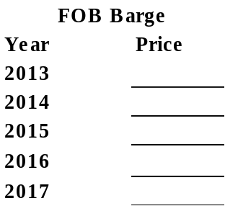

7. Type of Mine(s):
Surface | %
Underground | %
8. Mine District:
9. Name of Seam(s):
10. Preparation:
Crushed, run-of-mine | %
Washed | %
11. Comments:

Term Coal Proposal Form
Page 3 of 5
TERM COAL PROPOSAL FORM

- Guaranteed “Term” coal specifications “As-Received”:

The quality of coal being offered herein is intended to meet one of the following specifications as stated on the Coal Specifications:
❑ Specification A  Specification B

Table 1

Parameter | Contracted Monthly  Weighted  Average  Average | Suspension |  | Rejection
Parameter | Contracted Monthly  Weighted  Average  Average | Half-Month |  | Applicable Lot***
Parameter | Contracted Monthly  Weighted  Average  Average | Wtd. Avg |  | Wtd. Avg
Parameter | Contracted Monthly  Weighted  Average  Average | minimum | maximum | minimum | maximum
Calorific Value (Btu/lb.) |  |  | N/A |  | N/A
Moisture (%) |  | N/A |  | N/A
Ash (%) |  | N/A |  | N/A
Volatile Matter (%) |  | N/A | N/A |  | N/A
Hardgrove Grindability |  | N/A | N/A |  | N/A
**Sulfur Dioxide  (lbs. SO₂ per mmBtu) |  | N/A |  | N/A
Ash Fusion Temp.  (H=½W) ºF Red. Atm. |  | N/A | N/A |  | N/A
**Ash Loading  (lbs. Ash/mmBtu) |  | N/A |  | N/A
Mercury (ppm) |  | N/A | N/A | N/A | N/A
Sizing | 2” x 0 | N/A | N/A |  | 2.0”
** Half-Month Suspension should be reasonably close to the contracted specification
*** Applicable Lot refers to each barge load of coal or at Buyer’s election a composite of two or more barges of coal

Term Coal Proposal Form
Page 4 of 5

BARGE TRANSPORTATION FACILITIES INFORMATION

The following information is required for each barge coal origin that is being bid:

Loading Dock

River Milepost

1) What is the maximum number of Jumbo Barges that can be loaded in an eight-hour shift?

2) How many shifts per day are barges loaded?

3) How many days per week are barges loaded?

4) How many loaded and empty Jumbo Barges can be accommodated in the harbor of the above named Loading Dock?

5) Does this Loading Dock require the use of a harbor service for fleeting and switching?

6) If the answer to #5 is Yes, please identify the required harbor service.

7) Can the loading of barges commence at any time on any day upon arrival of the barges?

8) How fast after loading can an advanced shipping manifest be FAXED to a location?

If there are any questions regarding this information being sought, please contact Jeff Dial at (614) 583-6972.

Signature

Title

Company

Term Coal Proposal Form
Page 5 of 5

THIS IS A FIRM OFFER TO SUPPLY COAL UNDER ALL TERMS AND CONDITIONS INCLUDED IN THIS COAL PROPOSAL PACKAGE, AND SHALL BE HELD OPEN BY SELLER FOR AEPSC’S ACCEPTANCE THROUGH 5:00 P.M., FRIDAY JUNE 15, 2012. UNTIL AEPSC’S ACCEPTANCE HEREOF, WHICH SHALL BE AT ITS SOLE DISCRETION, THIS PROPOSAL SHALL NOT CONSTITUTE A VALID AND ENFORCEABLE AGREEMENT, BUT UPON AEPSC'S ACCEPTANCE, SUCH PROPOSAL SHALL CONSTITUTE A VALID AND ENFORCEABLE AGREEMENT BETWEEN AEPSC AND SELLER.

Proposal submitted by:

(Signature)

(Title)

(Company)
"DECLINE TO OFFER" FORM

TO AEP: THIS FORM WILL SERVE AS OUR NOTICE TO YOU THAT WE ARE NOT SUBMITTING A PROPOSAL IN RESPONSE TO THIS CURRENT SOLICITATION.

PLEASE (CHECK ONE):  RETAIN US ON THE LIST FOR FUTURE SOLICITATIONS

 TAKE US OFF THE LIST FOR FUTURE SOLICITATIONS

COMPANY SIGNATURE

ADDRESS DATE

PHONE

RETURN BY: May 31, 2012

❐ First Fold 
----------------------------------------------------------------------------------------------------------------------------------------------------------------Tape Here --

❐ Second Fold 
----------------------------------------------------------------------------------------------------------------------------------------------------------------
Place Postage Here

AEPSC RFP – COAL PROPOSAL
ATTN: JASON RUSK, DIR., EASTERN FUEL PROCUREMENT
AMERICAN ELECTRIC POWER SERVICE CORP.
155 W. NATIONWIDE BLVD.
SUITE 500
COLUMBUS, OH 43215

